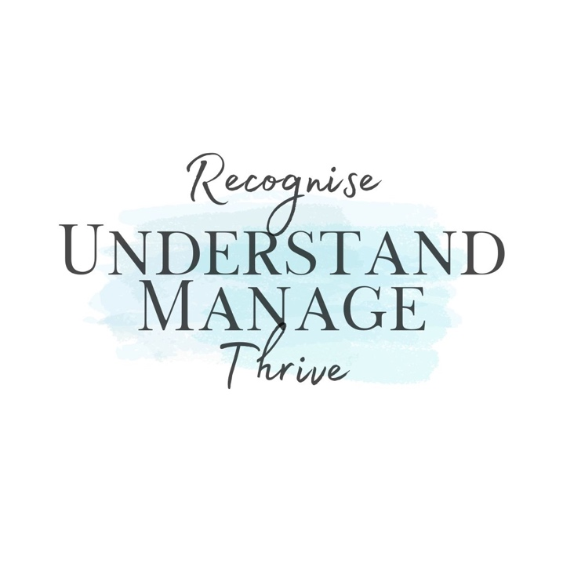

Please complete the referral form below if you would like support or advice for a child or young person who might be struggling with their emotional wellbeing.

Child’s Name |  | DOB
Name of School, or Educational Establishment.
(Please name the school that the child is currently registered to, attended last, or was last registered to, if de-registered.)

Your Name |  | Relationship to Child
Email Address |  | Contact number (opt)
Home Address

What is going well for the child? (e.g. Academic, social, emotional, goals and ambitions etc.)
What are you concerns about the child?

The child is currently | (place X in the box)
Attending School Full time, with support
Attending School Full time, no support
Attending School on a reduced timetable
Attending School on a managed phased Return
Not Attending School, Home based support
Not Attending School, No Support
Attending an Alternative Provision
Awaiting a place in an Alternative Provision
De-registered from School
Other:

How long has the child been impacted by difficulties attending school | (place X in the box)
Starting to show difficulties
1 – 6 Months
6 – 12 Months
12 – 18 Months
Over 18 Months
Other:
Additional Comments:

How would you describe the child | (place X in the box)
Neurodivergent (diagnosed)
Neurodivergent (undiagnosed)
Mild-Learning Difficulties
Profound-Learning Difficulties
Mental Health Needs
Behavioural Needs
Looked After
Other
Additional Comments:

What support is in place, or has been in place in the past?

Do you have any additional information to add, if not already mentioned?

Name
Date
Signature

Would you be willing for your information to be used for research purposes, with specific details changed to keep anonymity (name, age, schools, location etc.). You can change your mind at a later date if necessary. You can speak to DASH Mental Health, Wellbeing & Behaviour about this if you are unsure. | Yes
 | No
Would you be happy for any information collected through assessments and questionnaires to be used as research. Specific details will be changed to keep anonymity (name, age, schools, location etc.). You can change your mind at a later date if necessary. You can speak to DASH Mental Health, Wellbeing & Behaviour about this if you are unsure. | Yes
 | No
If you are responded yes to the above, please create your own unique identifier using the following format: Last two letters of your surname and the day and month of your date of birth in a 4 digit format. eg. Jones October 5th would be ES0510
The following section is just for survey purpose. It is looking at specific factors around you and your child.

Adverse Childhood Experiences (ACEs) are:
- Physical abuse.
- Sexual Abuse.
- Emotional Abuse.
- Physical Neglect.
- Emotional Neglect.
- Living with someone who abused drugs/alcohol.
- Exposure to domestic violence.
- Living with someone who has gone to prison.
- Living with someone with serious mental illness.
- Parental Divorce/Separation.
(put an x in the relevant box)
Care experienced
Young Carer
Free School Meals
1 to 3 ACEs
Over 4 ACEs
Trauma
Currently under CAMHS
Discharged from CAMHS

